Notes on Representing Polyomino Shapes

Each polyomino shape is represented by a List<int[]> of relative coordinates from the origin.

Example:

Making the top left cell the origin, this T shape can be represented as:

{ {0,1}, {0,2}, {1,1}, {2,1} }

All pentominos:

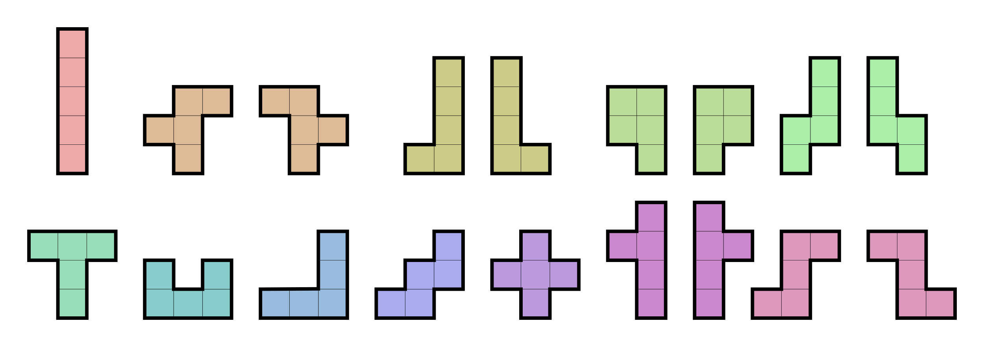

If using this approach, we will need to hardcode all rotations of all pentominos (probably roughly 60-70 total).